Chapter 2: The Constitution

1. The Origins of the Constitution
   1. The Road to Revolution
      1. Britain began tight enforcement of tax and trade regulations
      2. Colonists lacked direct representation
      3. Boycotted the British by throwing 342 chest of tea into Boston Harbor
      4. British sent a navy blockade to the harbor
      5. Colonists formed the First Continental Congress in September 1774
   2. Declaring Independence
      1. Thomas Paine distributed *Common Sense* which encouraged the colonists to declare independence from Britain.
      2. July 4th 1776 the Congress adopted the Declaration of Independence
      3. The Declaration is both a statement of philosophy and call to arms
   3. The English Heritage: The Power of Ideas
      1. John Locke was a major influence for the colonists
      2. Locke believed in natural rights
         1. Natural Rights – rights inherent in human beings, not dependent on governments
      3. Locke believed government should be built on the consent of the governed
      4. Locke believed in a limited government with restrictions on power
      5. Locke’s phrase “life, liberty, and property” was altered to “life, liberty, and the pursuit of happiness” by Jefferson.
   4. The American Creed
      1. All people have natural rights that are guaranteed by the government
      2. “self-evident”
      3. First government to be based on these citizen focused rights
   5. Winning Independence
      1. In 1775 the British has 8,500 men and 30,000 mercenaries.
      2. Colonist had 5,000 men in uniform
      3. Colonists won.
   6. The “Conservative” Revolution
      1. The Revolution didn’t juristically change the colonist’s way of life, it just ensured its survival.
2. The Government that Failed: 1776-1787
   1. The Articles of Confederation
      1. The first constitution of the Untied States, adopted by Congress in 1777 and enacted in 1781. The articles established a national legislature, the Continental Congress, but most authority rested with the state legislatures.
      2. Weak and ineffective government
      3. States held all of the power
   2. Changes in the States
      1. Now, the common folk held more power
      2. Not just the wealthy merchants and landowners that made the moves before the revolution
      3. The structures of state governments became more responsive to the people.
   3. Economic Turmoil
      1. Postwar depression left many farmers unable to pay their debts
      2. States threatened foreclosure
      3. Daniel Shays started the Shays’ Rebellion
      4. Shays attacked courthouses to prevent judges from foreclosing on farms.
      5. No state could form a militia strong enough to take out the rebellion so the elite chipped in and took them out.
      6. This movement fueled the dissatisfaction with the Articles of Confederation.
   4. The Aborted Annapolis Meeting
      1. September 1786, leaders met in Annapolis to discuss problems with the Articles of Confederation
      2. Only 5 states were represented
      3. Decided a larger meeting would need to take place
      4. In May 1787 the Constitutional Convention took place in Philadelphia
3. Making A Constitution: The Philadelphia Convention
   1. Gentlemen in Philadelphia
      1. 55 men included elite group of economic and political nobles.
      2. Wealthy college educated males
      3. Most were from urban costal region
   2. Philosophy in Action
      1. Human Nature
         1. Leviathan by Thomas Hobbes
         2. Hobbes argued that humans are in a constant state of war
         3. The colonists agreed with Hobbes cynical view of the people.
         4. Government should play a key role in containing the natural self-interest of people
      2. Political Conflict
         1. “The distribution of wealth is the source of political conflict”
         2. There are two types: those who hold property and those who do not
         3. Factions began to arise; we know them today as political parties
      3. Objects of Government
         1. Morris believed that governments main objective was about preservation of property
         2. Government should enable individuals to acquire and hold wealth
         3. Few, like Morris, were set on not giving non-property owners the right to vote
      4. Nature of Government
         1. Power should be set against power so no faction could become too strong
         2. “balanced” government is a good government
         3. limited government would have checks on its power
         4. no faction could seize the entire government and tyranny would be avoided
4. Critical Issues at the Convention
   1. The Equality Issue
      1. Conflicts arose surrounding states votes, slavery, and equal representation
      2. Equality and Representation of the States
         1. New Jersey Plan
            1. Each state is represented in the congress
         2. Virginia Plan
            1. States would be given representation based on their populations
         3. Connecticut Compromise
            1. Two houses
            2. Senate gets 2 members from each state
            3. House of Representatives gets representation based on the population
         4. Small states ended up having proportionally more power over larger states
            1. Wyoming has same amount of representation in the senate as California does
      3. Slavery
         1. Slavery was not forbidden by the convention
         2. Too much conflict between northern states and southern states that required it for their economy
         3. Argued over representation of slaves
         4. 3/5 Compromise
            1. 1 slave counts towards states population as 3/5 of a person
      4. Equality in Voting
         1. Franklin suggested universal manhood suffrage
         2. Some wanted property owner ship to be a requirement for voting
         3. This was left to a state issue
   2. The Economic Issues
      1. Wanted to address the following problems
         1. States had erected tariffs against products from other states
         2. Paper money was worthless in some states
         3. Congress was having trouble raising money because the economy was in a recession
      2. Framers wanted to create a stronger economy
      3. Government could raise money though taxing or borrowing
      4. Constitution obligated the new government to pay all public debts caused by the Continental Congress and the Articles of Confederation
   3. The Individual Rights Issues
      1. Creating a system that preserved individual rights was a key goal in the creation of the Constitution
      2. Believed that states were doing enough to protect individual rights therefore the constitution says little about personal freedoms
      3. Mentions
         1. Writ of habeas corpus
            1. A court order requiring jailers to explain to a judge why they are holding a prisoner custody
         2. Prohibits bills of attainder
         3. Prohibits states from passing ex post facto laws which puts statue of limitation on crimes
         4. Prohibits religious affiliation from being a determinate in holding public office
         5. Defines treason
         6. Trial by jury
5. The Madisonian System
   1. Thwarting Tyranny of the Majority
      1. Madison was not a good orator or wealthy. He was a careful student of politics and government.
      2. Madison wanted to protect the tyranny of the majority so he proposed the following:
         1. Place as much of the government as possible beyond the direct control of the majority
         2. Separate the powers of different institutions
         3. Construct a system of checks and balances
      3. Limiting Majority Control
         1. Madison placed only one part of the government in control of the majority, the House of Representatives
         2. Limited terms for senators to six years, House of Representatives has 2 year terms because of their direct relationship to the majority.
      4. Separating Powers
         1. Created the three branches of government
         2. Gave president, congress, and the courts independent elements of power that need to work together to get things done.
         3. 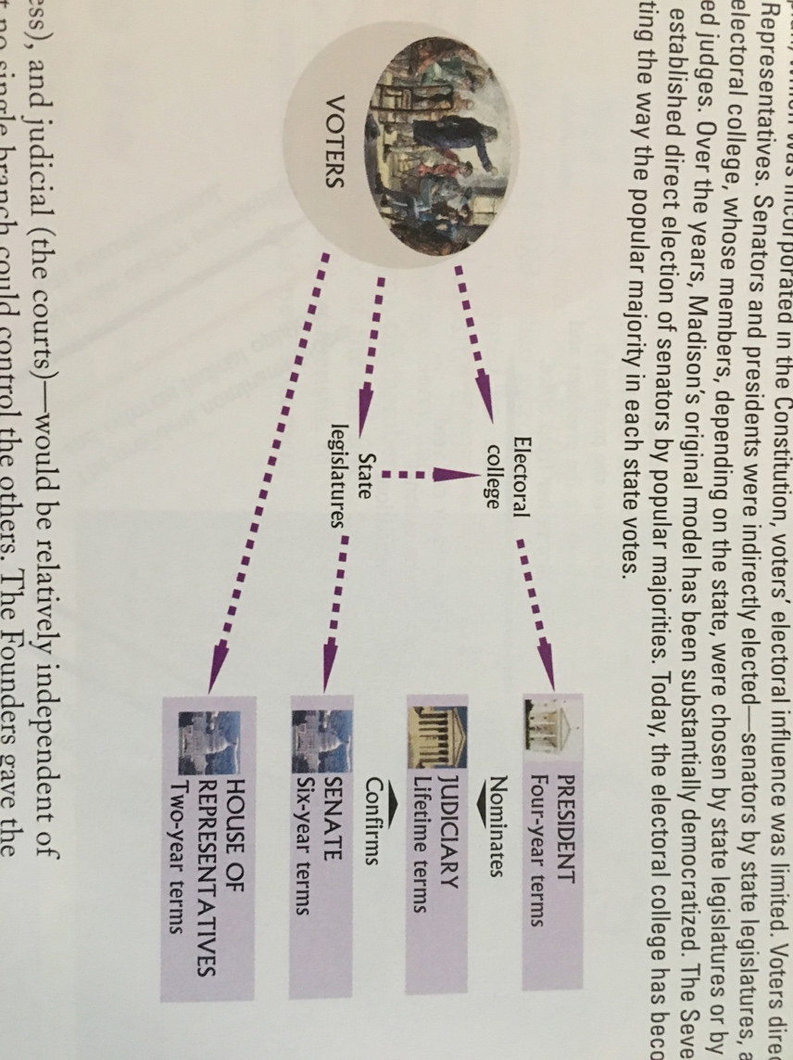
      5. Creating Checks and Balances
         1. Checks and balances
            1. Features of the Constitution that limit governments’ power by requiring that power be balanced among the different governmental institutions. These institutions continually constrain one another’s activities.
         2. Establishing a Federal System
            1. Power was divided between national and state governments
            2. This gave an additional check on the national government
   2. The Constitutional Republic
      1. Country was too large for a direct democracy
      2. Erected a republic
         1. Republic: a form of government in which the people select representatives to govern them and make laws
   3. The End of the Beginning
      1. The constitution was completed on the 109th day of meetings in Philadelphia.
6. Ratifying the Constitution
   1. Constitution broke the Articles of Confederation by allowing it to pass with only 9 states out of 13. The AOC would have required a unanimous consent
   2. Federalist and Anti-Federalist
      1. Federalists
         1. Supporters of the US Constitution at the time that states were contemplating its adoption
      2. Anti-Federalists
         1. Opponents of the American Constitution at the time when states were contemplating its adoption
         2. Believed this new document was en enemy of freedom and took away the very freedom they just fought to protect
         3. Said that new document would erode fundamental liberties
         4. Complained about no rights being listed in the Constitution
         5. Federalists added the Bill of Rights
      3. Bill of Rights
         1. The first 10 amendments to the US Constitution drafted in response to some of the Anti-Federalist concerns. These amendments define such basic liberties as freedom of religion, speech, and press and guarantee defendants’ rights.
   3. Ratification
      1. Federalists had bigger political outreach
      2. Delaware was the first to approve of the Constitution
      3. NYC was the nations first capital
7. Changing the Constitution
   1. The Formal Amending Process
      1. The most explicit way of changing the constitution is through the formal process of an amendment.
      2. 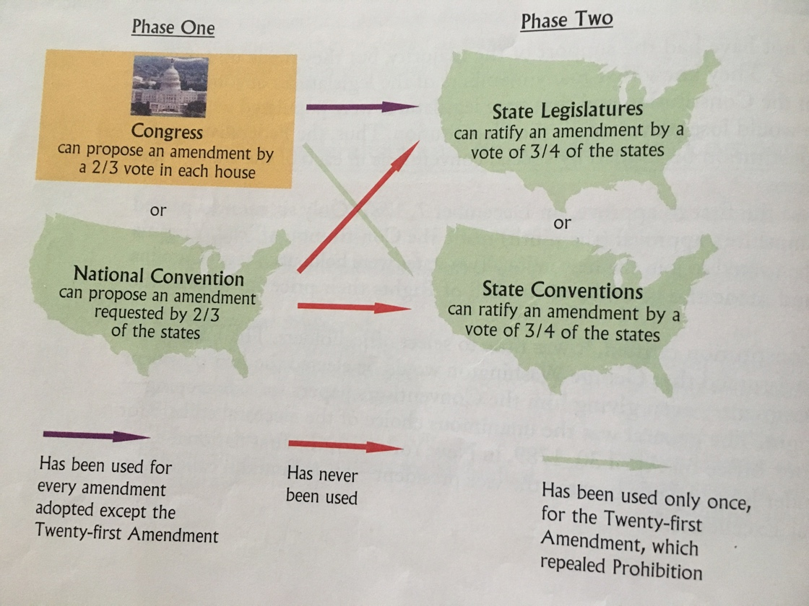
      3. Equal Rights Amendment was proposed by not ratified
         1. Blocked because southern states opposed it.
   2. The Informal Process of Constitutional Change
      1. Judicial Interpretation
         1. Marbury v Madison
            1. Gave the Supreme Court the power of Judicial Review

The power of the courts to determine whether acts of congress and, by implication, the executive are in accord with the US vs constitution.

* + - 1. Changing Political Practice
         1. Toady we have political parties, and have changed the constitution to support the modern style of presidential elections.
      2. Increasing Demands on Policymaking
         1. The significance of the president has grown since the creation of the constitution.
         2. President’s now are much more involved in international affairs.
         3. All wars increase presidential power because they place additional demands on the commander in chief.
         4. Patriot Act gave the executive branch unprecedented power.
    1. The Importance of Flexibility
       1. The constitution is a document of less than 8,000 words. There are not rules for everything, it is just a framework.
       2. Therefore, it is adaptable in its interpretation
       3. The Constitution is still growing.

1. Understanding the Constitution
   1. The Constitution and Democracy
      1. Constitution established a government that permitted substantial movement toward democracy
      2. 15th amendment
         1. prohibited discrimination on the basis of race in determining voter eligibility
      3. 19th amendment
         1. gave women the right to vote
      4. 23rd amendment
         1. residents of DC are permitted to vote in presidential elections
      5. 24th amendment
         1. prohibited poll taxes
      6. 26th amendment
         1. lowered the voting age to 18
   2. The Constitution and the Scope of Government
      1. The Constitution limits governmental action
      2. This creates more protection for liberty and opens the system to much more participants